**REMEMBER…**

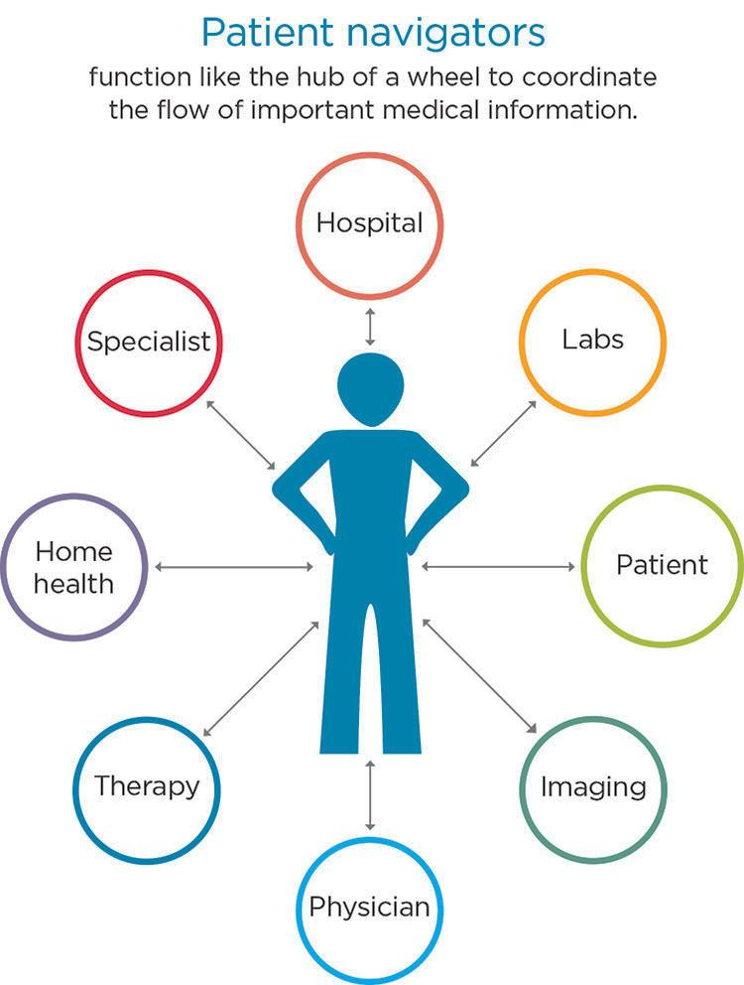



**807-854-0051** (ext.227)

**Or**

**863-0052**