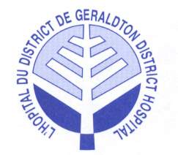
Geraldton District Hospital

May 30, 2018

Patients are at the centre of hospital’s new strategic plan

On May 30, 2018, the hospital celebrated the launch of their new strategic plan. The festivities were held in the hospital foyer from 1:30pm to 3:00pm. Numerous speakers took part with an unveiling of the new Mission, Vision and Values.

Geraldton District Hospital launched a new Strategic Plan that begins a new journey in Patient and Family Centred Care (PFCC). “It focuses on what matters most: keeping patients and families at the centre of quality safe, care,” said Lucy Bonanno, Hospital CEO. “PFCC is a shift from doing something for a patient, to partnering with a patient. Not only when delivering care directly, but also when planning, designing and evaluating every aspect of our services.”

PFCC is at the heart of the new Mission, Vision and Values for the Hospital.
Those are:
Mission: We are committed to delivering Quality, Coordinated Patient and Family Centered Care.
Vision: Partnering for a Healthier Community.
Values: Respect: We respect and promote the dignity of each individual.
Excellence: As a team we provide quality inspired and seamless care to our patients/residents and their families.
Accountability: We are accountable to the communities we serve through ensuring that available resources are utilized efficiently and appropriately.

Three Strategic Pillars will guide GDH activities and initiatives for the next five years:

Patient and Family Centred Care: We will continually work along-side those we serve to create ideal experiences that are inspired by our patients. We will rethink and invent fresh, new ways to connect and interact with patients and their families to better meet individual needs and ensure that patients get the right care at the right time in the right place.

Partnerships: Together we will promote healthy living to help individuals live independently in their homes and to prevent and manage chronic conditions. Redefining the meaning of ‘hospital’ and transforming our relationship with partners will enhance care delivery in our region and transcend traditional boundaries of the hospital, community, and at-home care.

Access to Care: We will strive to meet the changing and increasing needs of our community and maximize our human and fiscal resources. Our focus on clinical best practice will extend across all areas of the organization to provide standardized clinical pathways to improve patient outcomes while allowing us the flexibility to improve access to care across our community.

“This is our promise to the people of our community,” said Jamie McPherson, Board Chair. “With the commitment of the Board, leadership, physicians, staff and volunteers behind it, I have every confidence that we will deliver on that promise and ultimately enhance experiences and outcomes for patients and their families."

Setting the Strategic Directions and monitoring of Strategic Plan progress are key responsibilities of the Board of Directors. “On behalf of the Geraldton District Hospital, I would like to thank our staff, community and partners for their commitment to the new Strategic Plan,” McPherson said. “Their participation will have a long-standing impact on patient care here in our community.”

To see the full Strategic Plan, please visit www.geraldtondh.com

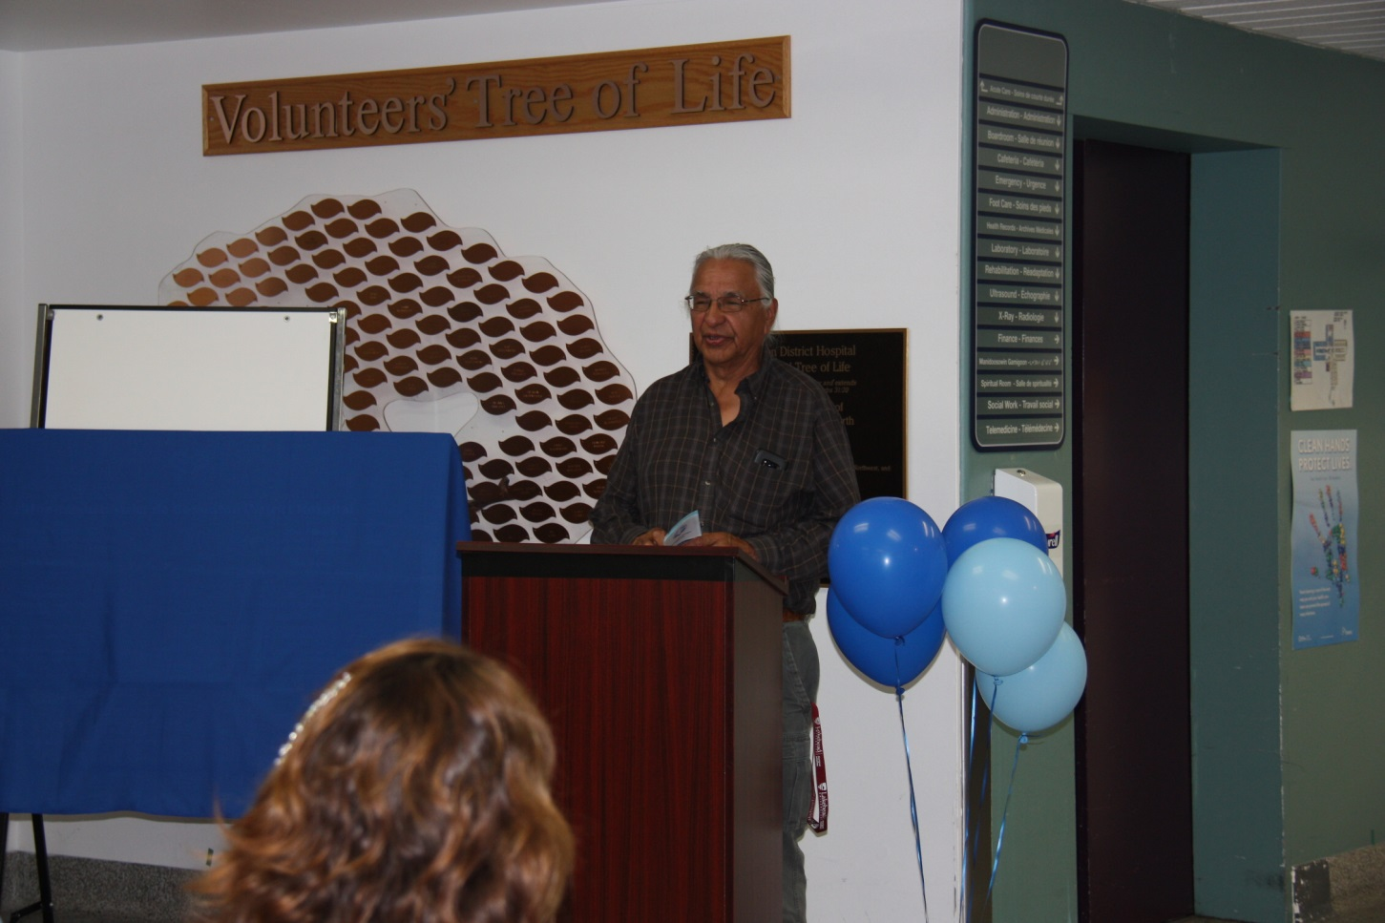
Speakers: Victor Chapais, a respected Elder in our community started off the program with a prayer and a personal story of his time growing up with his father and grandfather in the traditional ways and how healthcare has changed and progressed.
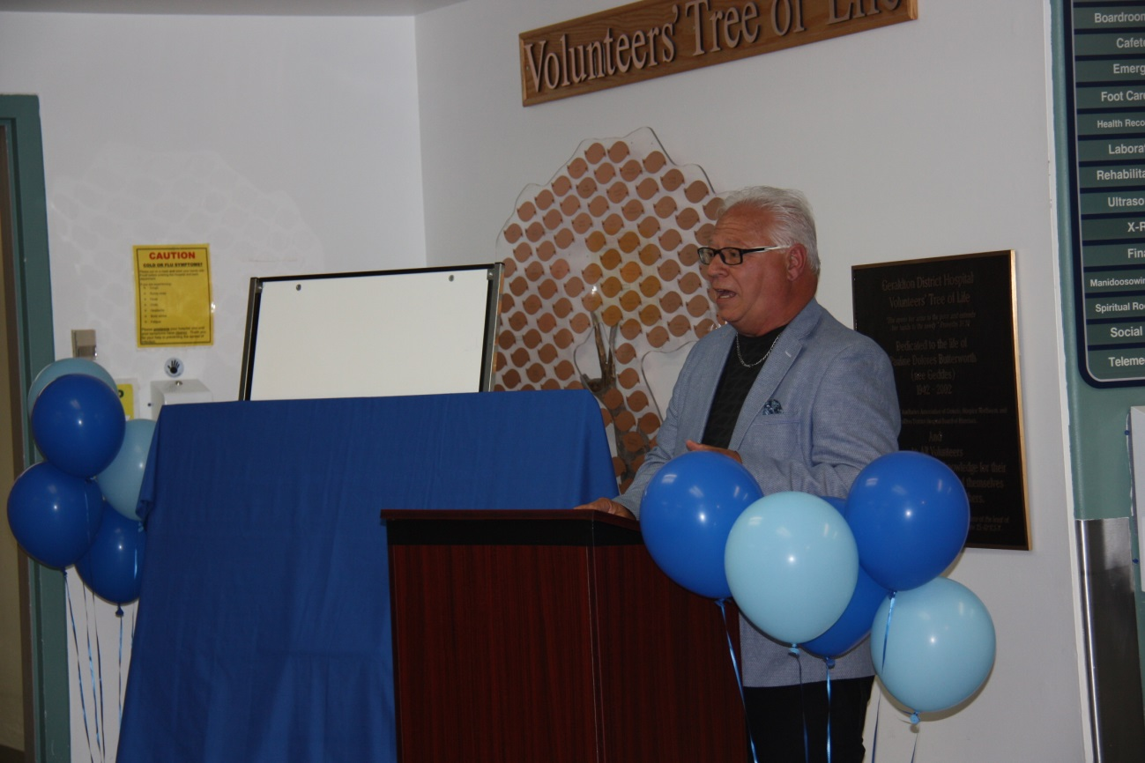
Mayor Beaulieu of Greenstone spoke about how change is necessary to move forward.
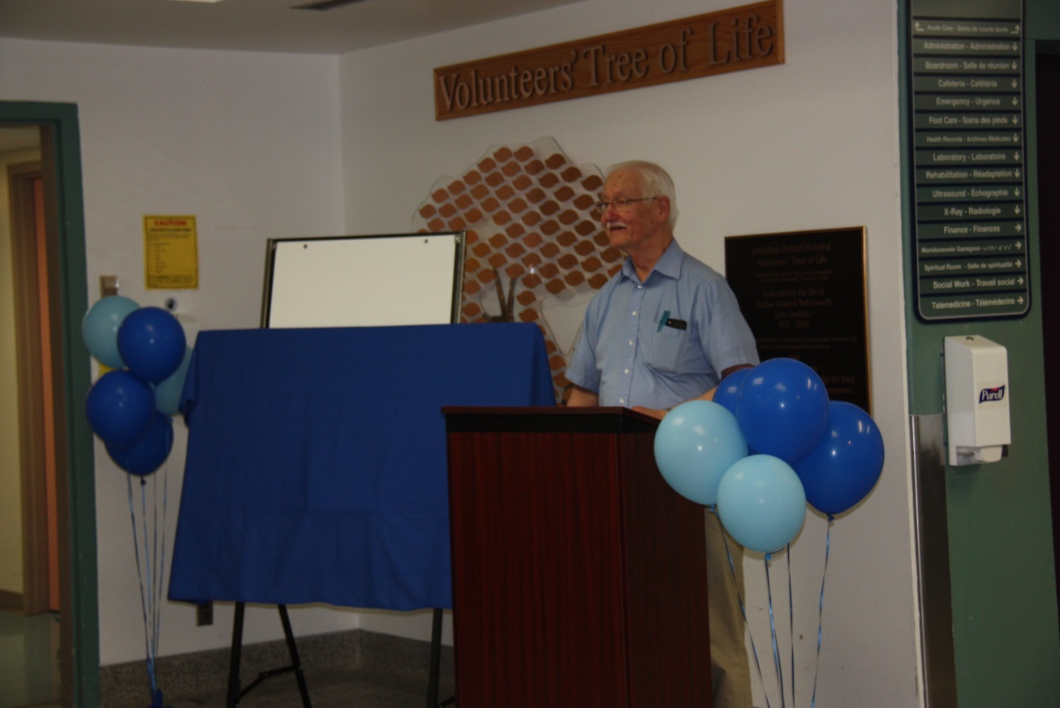
Dr. R. Laine, a long standing highly respected physician at the hospital, spoke on how we have much to be grateful for in our community related to healthcare services offered.
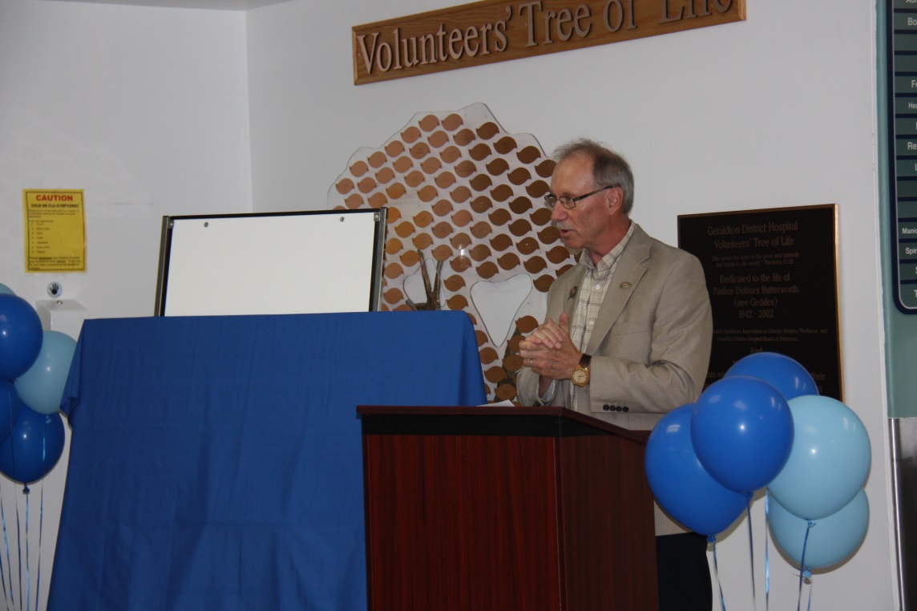
Jamie McPherson, Chairman of the Board, spoke on how partnerships are a necessity in today’s world of healthcare.
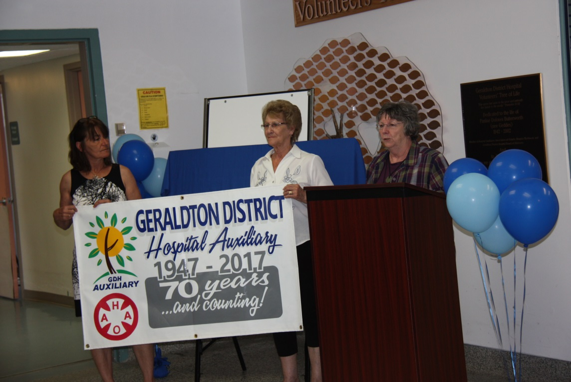
Myrna Letourneau, President of the Auxiliary, spoke on the strong partnership between the volunteers and the hospital.

