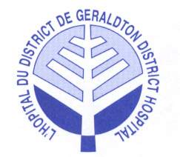

Occupational Therapist
Temporary Full-time

Applications are invited for one (1) temporary full-time Occupational Therapist position at the Geraldton District Hospital. This position is available from mid-April to mid-January 2018. This position is under the Unifor Paramedical collective agreement.

Come and experience the satisfaction of a challenging professional work environment. Your caseload will include out-patients, in-patients and long-term care residents, home and work assessments.

Qualifications:
- Degree of Occupational Therapy or equivalent from an accredited occupational therapy program
- Current registration with the College of Occupational Therapists of Ontario
- A valid driver’s licence and access to a reliable vehicle
- ADP Authorizer qualification is an asset (seating/positioning and ambulation category / wheelchairs and walkers)
- Related experience in a LTC and hospital setting is an asset
- Knowledge of Med e-Care and Meditech software programs is an asset
- Ability to communicate in both official languages is an asset
- Good attendance record is mandatory

Take advantage of this unique opportunity to enhance your professional and personal growth in our team-based environment, while experiencing life in a rural Northern Ontario community.

Geraldton District Hospital is committed to workplace diversity and provides accommodations to applicants with disabilities throughout the hiring process.

Applications will be reviewed on April 7, 2017; however the position will remain open until a suitable candidate is hired. Please submit your application with resume to the attention of:

Sylvie Duranceau
Director of Clinical Services
E-mail: sduranceau@geraldtondh.com
www.geraldtondh.com

Thank you for your application, however, only those applicants selected for an interview will be contacted.

