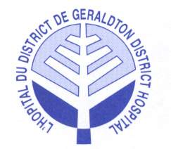
Patient Rights Regarding Personal Information

The Geraldton District Hospital is responsible for personal health information under its custody or control. As a health information custodian, the Hospital is committed to protecting the privacy, confidentiality and security of all personal health information to which it is entrusted.

At the Geraldton District Hospital, patients’ rights are respected regarding their health information including the right to:

- Consent or refuse collection, use and disclosure of your personal health information
- Access your personal health information and/or request copies of the complete record or specified sections
- Request to amend your personal health information
- Request an accounting of disclosure of your personal health information, as well as who has accessed or used your personal health information
- Request restrictions or limitations on your personal health information the Hospital may use or disclose about you for treatment, payment or health care operations
- Request confidential communications
- Challenge the Hospital’s compliance with privacy laws

The role of the Privacy Officer at the Geraldton District Hospital is to serve as a resource for privacy issues and provides the following services:

- Advocate for patient and staff privacy within the organization
- Act as the privacy resource/expert
- Facilitate implementation of privacy laws and principles
- Develop privacy related policies and procedures
- Evaluate the Hospital’s processes to ensure compliance

