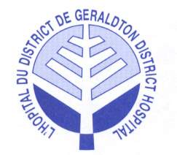

Existing Key Clinical Services

- Emergency services 24/7

- Diagnostic services:
  - Radiology
  - Ultrasound
  - Laboratory
  - Electrocardiography

- Ambulatory Care
  - Medical & Surgical Day Procedures
  - Chemotherapy Outreach
  - Physiotherapy
  - Occupational Therapy
  - Clinical Nutrition Services
  - Social Work
  - Foot Care for Seniors
  - Specialty Clinics by Telemedicine

- Inpatient Care
  - Acute Medical/Surgical
  - Respite Care
  - Alternate Level of Care

- Long-Term Care
  - Residential Care
  - Complex Continuing Care

Over the next four years, Geraldton District Hospital (GDH) plans to optimize its resources focusing on quality improvement, efficiency and health and safety for patients, staff, physicians, volunteers and visitors.

Geraldton District

Hospital
Strategic Plan

May 2014

Toward a Healthier Community

A Roadmap to the year 2018

Pocket Guide

Version française disponible

Our Mission

Community-based culturally-sensitive quality care

Our Vision

Coordinated quality health care through established working linkages and partnerships.

Our Values

To provide safe client-centered multi-disciplinary quality care

To respect the dignity and diversity of our clients and human resources

To practice continuous quality
improvement

To provide a safe, healthy and accessible environment for clients, staff, volunteers and visitors

To be legally, ethically, fiscally and environmentally accountable

To learn and to evolve

The GDH Strategic Plan:

Is a road map for the future. It describes where the Geraldton District Hospital wants to be and how it will get there. The Plan encompasses the next four years and will impact and involve other health care providers in the communities of Greenstone and area.

Geraldton District Hospital strives to ensure access to high quality health care and information for residents to build a healthier community. The Hospital plans to accomplish this through the following three strategic directions and goals.

Strategies & Goals to fulfill the Plan are:

Partnerships
Collaborative planning with local, district and regional partners will help ensure that seamless services are provided to patients. GDH will continue to:
●Explore other potential partnerships that could improve quality and/or efficiency of services
●Work with the Healthier Community Advisory Committee
●Work with the Greenstone Family Health Team
●Contract Financial Management Services from Nipigon District Memorial Hospital
●Contract Human Resources Consulting Services from St. Joseph’s Care Group
●Contract Material Management and Biomedical Maintenance from Thunder Bay Regional Health Sciences Center
●Establish agreements with educational health care and medical programs
●Lead the development of the District of Thunder Bay IDN Health Link, as per the North West LHIN’s Blueprint and MOHLTC’s Action Plan for Health

Programs and Services
Considering the vast geography of the catchment area, it is imperative that all primary care programs and services are provided as close to home as possible.
●Maintain all existing services
●Explore other potential services, such as chronic disease management and ambulatory care programs to reduce unnecessary travel out of town
●Explore a shared care model for perinatal care
●Investigate options to better support women and their families when leaving the communities for birth
●Identify means to provide crisis response to sexual assaults and domestic violence
●Review the for non-medical service models of addiction rehabilitation

Cultural Competence
Given the cultural diversity of our region, it is essential to foster awareness and sensitivity to provide better care.
●Engage First Nations and Francophone populations to ensure a culturally safe and competent experience at Geraldton District Hospital
●Monitor demographic changes to ensure services are provided in a culturally diverse manner
●Review Corporate Bylaw to ensure First Nations and Francophone inclusion
●Continue providing annual diversity training to all staff

Geraldton District Hospital
500 Hogarth Ave. West
Postal Bag #4
Geralton, ON P0T 1M0
(807) 854-1862
www.geraldtondh.com

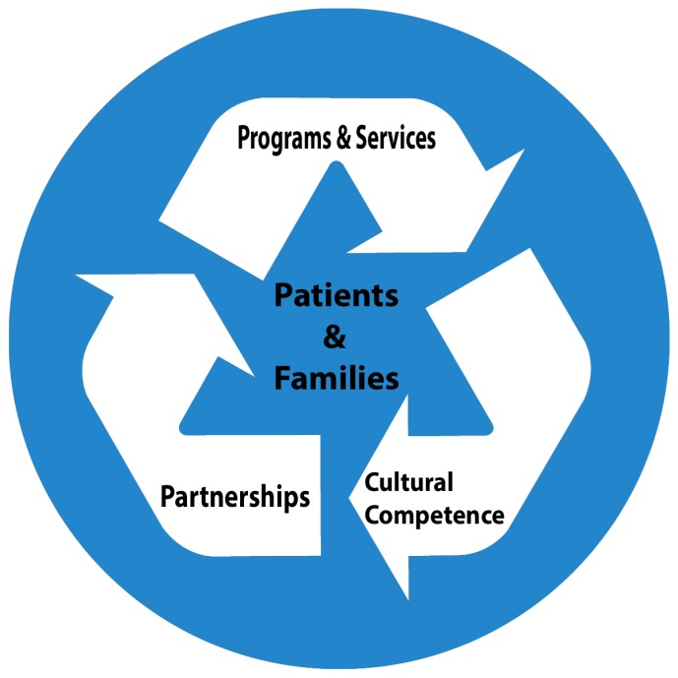

The three strategic directions are supported by the following four organizational strategic enablers:

Quality
Ensure a culture of continuous quality improvement and risk management

Efficiency
Deliver care and service in a cost-effective manner

Human Resources
Ensure recruitment and retention of qualified hospital staff and medical staff

Physical Environment
Provide appropriate facilities to deliver care and services.

