

Volunteers’ Tree of Life Recognition Awards 2018

The Geraldton District Hospital hosted the annual Volunteer Appreciation Social that was held on April 16, 2018, at 7:00pm; at which time the Volunteers’ Tree of Life Recognition Awards were presented.

The Volunteers’ Tree of Life was dedicated to the life of Pauline Dolores Butterworth (1942-2002) due to her commitment to the hospital and patients. She volunteered tirelessly. After her death, her husband Rev. Gerald Butterworth dedicated funds to begin the official ‘Tree of Life Recognition Award’. It is located in the main lobby of Geraldton District Hospital.

There is a list of criteria that the nominated individuals must meet that the Selection Committee reviews prior to making their selection. An Ad Hoc Hospital Committee comprised of hospital employees and volunteers, is struck to both formalize and maintain consistency in the process of nomination and selection of recipients of this award.

The guidelines are based on the criteria of:

* Qualities (contributions and commitment)
* Length of Service
* Altruism
* Impact on Hospital Mission, Vision and Values Statement
* Role Model to others
* Details of volunteer activities

The successful candidates for 2018 are:

*Joan Bull*

Joan has actively volunteered with the Auxiliary since 2009. She works in the Sunshine Gift Shop twice a month and often works extra shifts to ensure the shop is open as often as possible. She also bakes and sells tickets for events. Joan has always been active in the community and presently assists with the senior curling weekly program.

*Sharon Groeneveld*

Sharon has been volunteering with the Auxiliary since 2008. She works in the Sunshine Gift Shop, bakes for various events throughout the year and is very active in the community. She volunteers each year for the Walleye Classic, and is on the Geraldton Children’s Entertainment Committee. Sharon is also a member of various hospital committees’ and has been a Captain for the Heart and Stroke Association.

*Jamie McPherson*

Jamie has been an active member on the Board of Directors at the hospital since 2010. He was elected Chairman of the Board in 2013 and continues in this position today. Jamie is also active on various Board committees, such as, Quality Improvement and the Audit Committee. He is President of the Longlac Curling Club and has worked with the Junior Curling Program for the last 20 years. Jamie is a member of the Longlac Historical Society as well as a member of the GDH Auxiliary.

*Deanna Thibault*

Deanna was a director on the Hospital Board of Directors from 2005 to 2013. She held an executive position during her tenure on the Board. She has always been an active member of her community and in the past was president of the Economic Development Corporation and treasurer of the Greenstone Family Health Team. Deanna was also the coordinator of the Golf Fore the Cure fundraiser for breast cancer research while it was an annual event.

*(Note: Deanna Thibault was unable to make it in person due to the storm as she lives in Nakina.)*

It is with pleasure that these 4 names be permanently inscribed on a gold leaf on the Volunteers’ Tree of Life, located in the front foyer of the hospital.

I would like to send my sincere congratulations and thanks to this year’s recipients for their tireless work in our community! It is because of the commitment of all of our volunteers, that our communities are able to grow and continue to thrive, even during our challenging times!

Lucy Bonanno, CEO

Geraldton District Hospital

**Volunteer Tree of Life Social at Geraldton District Hospital – 2018**

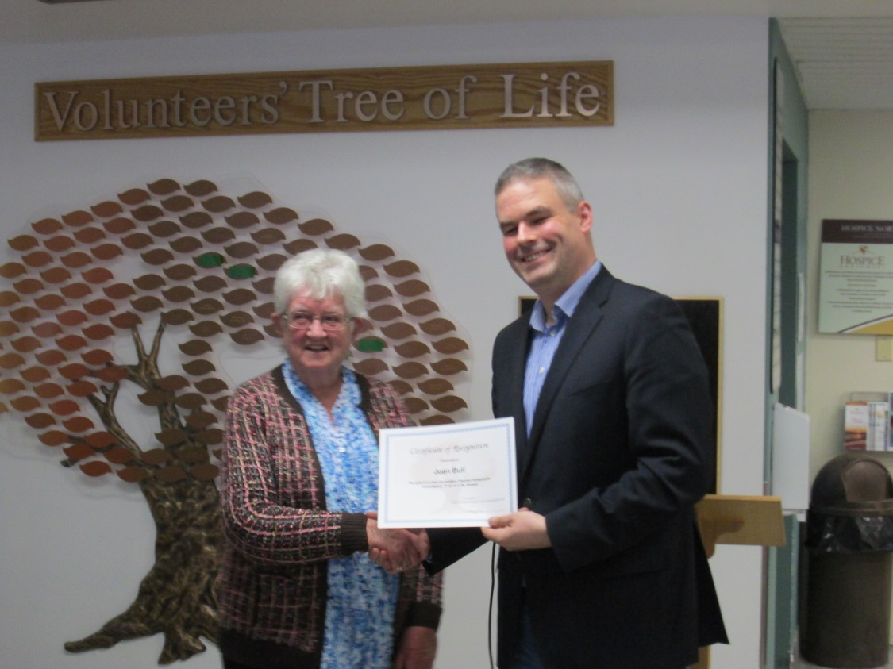

Left to Right: Joan Bull receiving congratulations from Mark Wright, Vice Chairman Board of Directors GDH

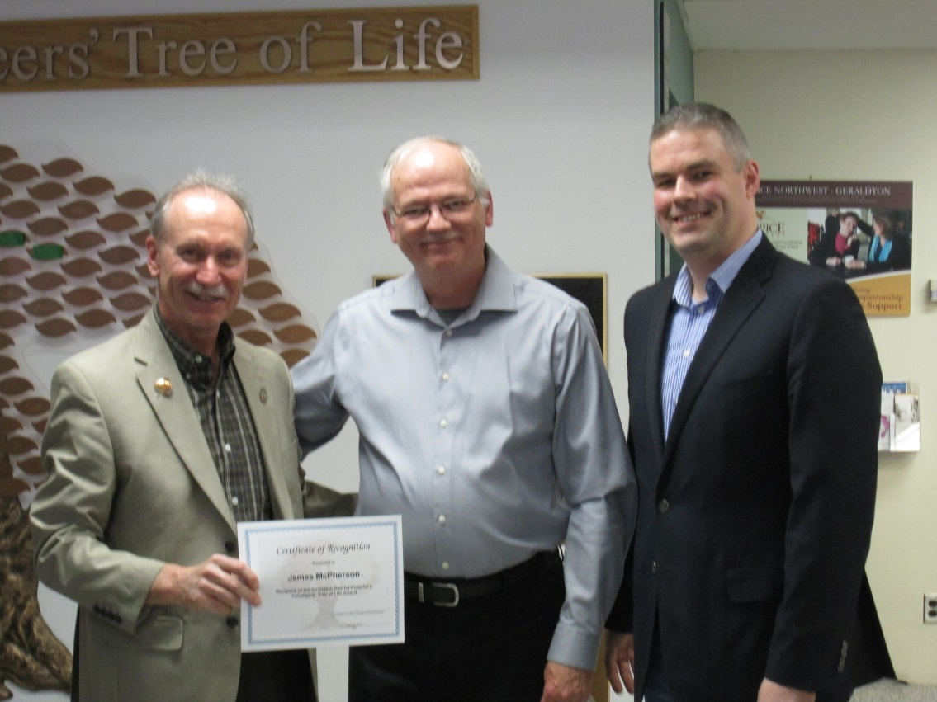

Left to Right: Jamie McPherson receiving congratulations from Ralph Humphreys, Board Member GDH and Mark Wright

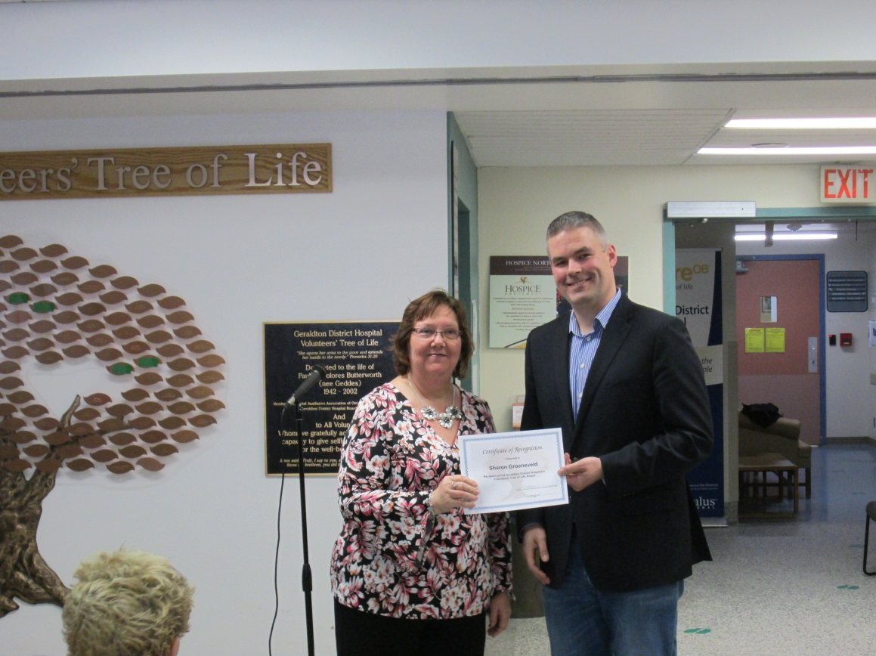

Left to Right: Sharon Groeneveld receiving congratulations from Mark Wright, Vice Chairman Board of Directors GDH

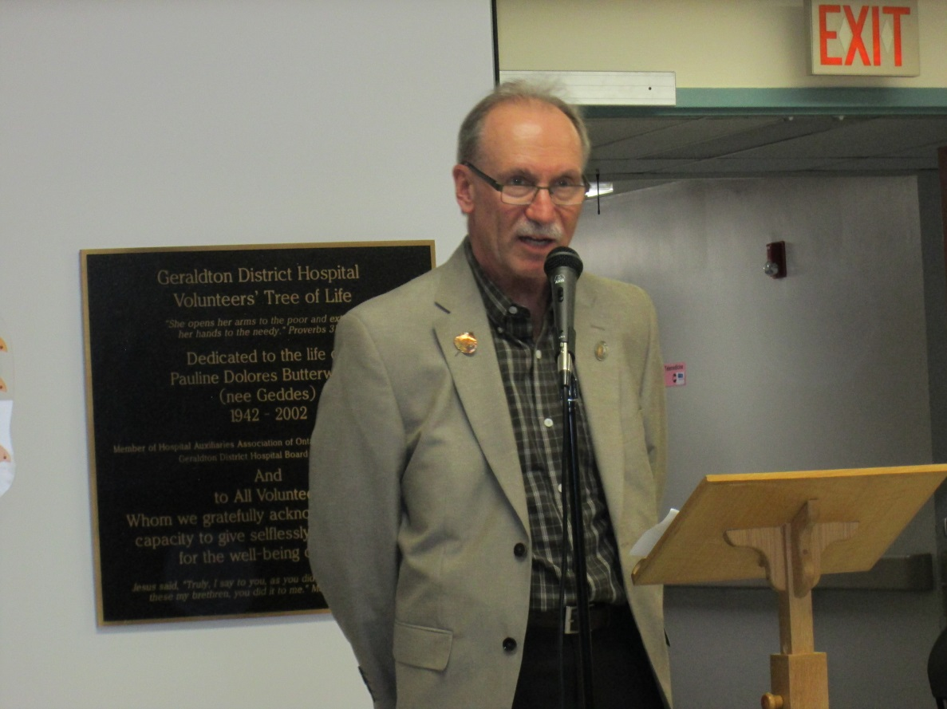

Jamie McPherson, current Board Chairman GDH addressing the audience at the volunteer social

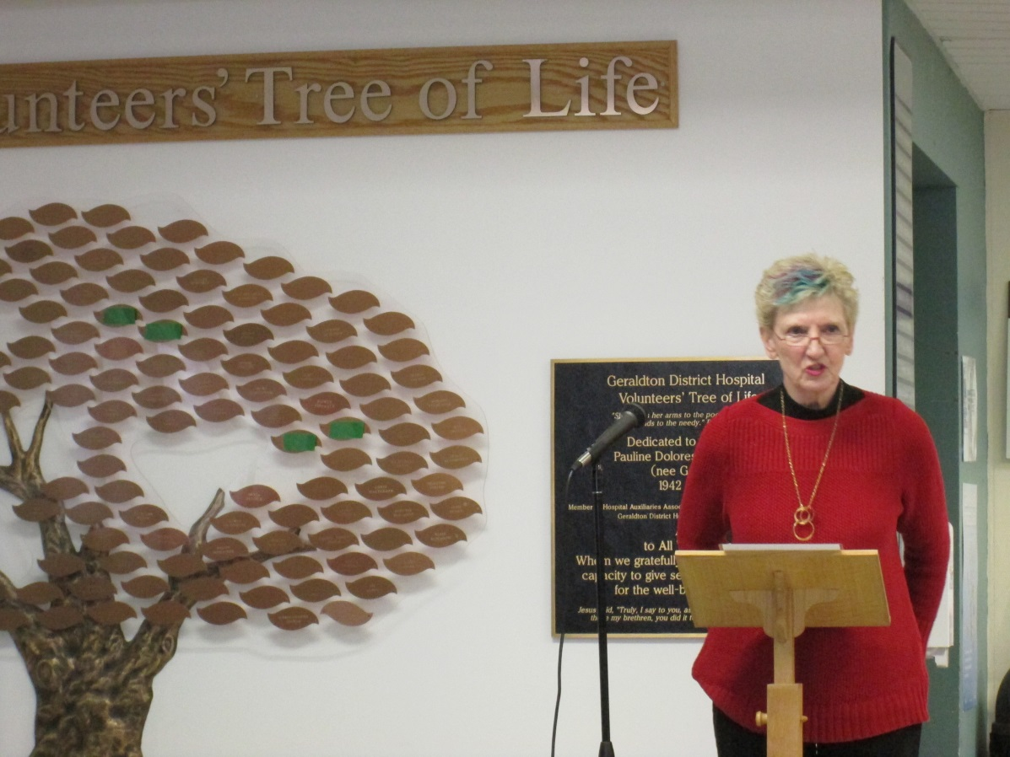

Dorothy Friske, HAAO President; one of the many organizers of the Tree of Life Volunteer Social, addressing the audience

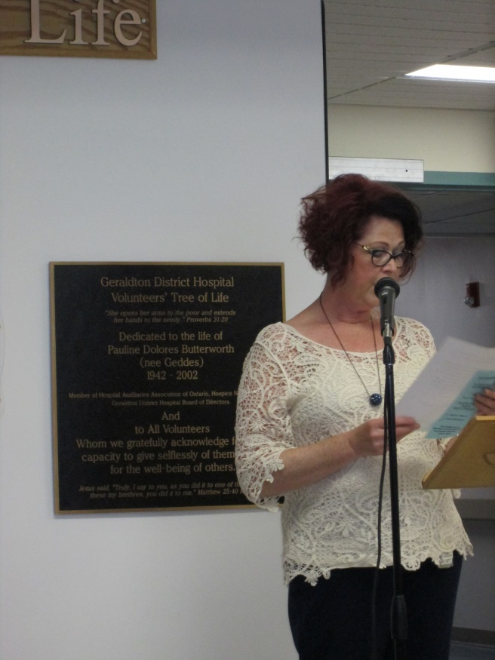

Ms. Laurie Heerema, CNE, addressing the audience